JasC Programming Language Manual Version 1.0

1. Compiling Applications 3
1.1 Writing & Building Applications 3
2. Basics 4
2.1 Variables 4
2.2 Special Registers 4
2.3 Arithmetic 5
3 Conditional Statements 5
3.1 Selection Statements 5
3.2 Iteration Statements 6
4 Function Calling 6
5 Variable Indexing 7
6 JasC language limitations 7
7 Appendices A – Keywords & Operators 8

Compiling Applications
JasC is a high-level language that uses a sub set of the ANSI C language. This chapter explains how to write and build JasC applications for the PIC16F84 microprocessor using JasC’s graphical user interface.
Toolbar containing buttons for creating new files, opening, saving and compiling JasC source files.
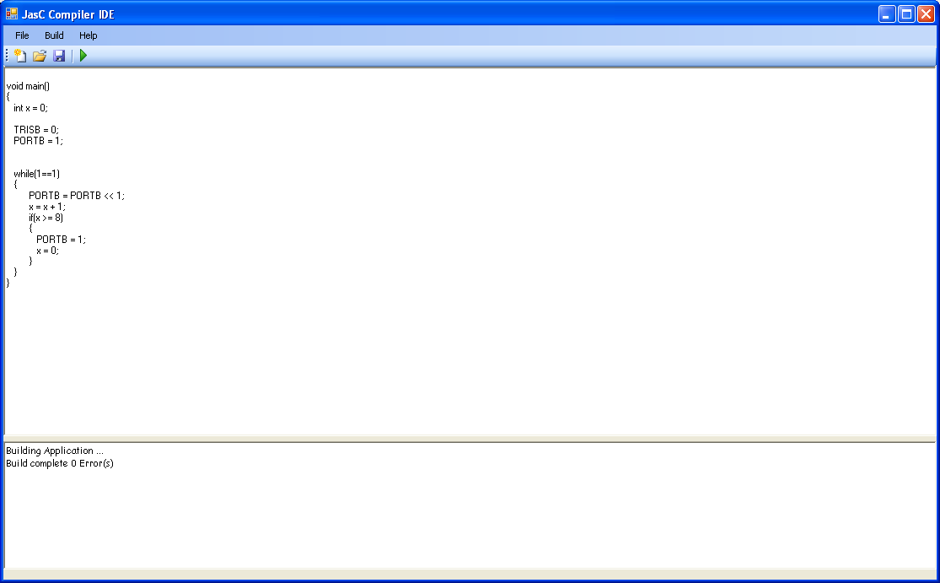
Figure 1 JasC Compiler Interface

Text area for creating and manipulating JasC files.

Status of the compilation process.

Error: Reference source not found shows the environment you can use to develop applications for the PIC16F84 microprocessor.

Writing & Building Applications
All JasC applications must contain a main() function. This function is called by the PIC processor before any other function is called. To write a JasC application you simply type source code into the text area shown in Figure 1. The following example program outputs the number 5 to PORTB. The code will be explained in later chapters.

- Open JasC Compiler
- Enter the following code:

void main()
{
TRISB = 0;
PORTB = 5;
}

- Save the source code otherwise the compiler will not compile the source code and will prompt you with an error message.
- Once the file has been saved click the build button shown in Figure 2. The compilation status will be shown in the compilation status window shown in Figure1.
Figure 2 Tool bar

In the directory where you saved the .JasC source file a new file with a .HEX extension will be created. This file is machine code, which should be downloaded to the microprocessor.

Basics
Variables are memory locations used to store values temporarily. The JasC compiler allows the developer to reference the memory locations using descriptive names. JasC currently supports type int, which can be used to store integer values.

Variables
All variable names are case sensitive and must being with an alphabetical character. The variable names can contain digits and underscores. If the variable does not begin with an alphabetical character the compiler will report a syntax error. Below is some examples of declaring variables.

int Result; // This variable is syntactically correct.
int Tina_Martens; // valid declaration;
int 1Variable; // Incorrect, compiler will report an error.

JasC also allows you to initialise variables and declare more than one variable per line. For example

int Jason = 1;
int Jason, Myerscough, Result;
int Number1 = 0, Number2 = 0;

Special Registers
The PIC16F84 microprocessor contains some special registers such as PORTA and PORTB, which are used for I/O. Developers can use these variable without having to declare them and they can be used like any other variable. The following code reads a number from PORTA and outputs the values to PORTB.

void main()
{
TRISA = 255;
TRISB = 0;

while(1==1)
PORTB = PORTA;
}

Table 1 lists all of the special registers available to the developer.

TMR0
PCL
STATUS
FSR
PORTA
PORTB
EEDATA
EEADR
PCLATH
INTCON
OPTION
TRISA
TRISB
EECON1
EECON2
Table 1Special Registers

Arithmetic
JasC allows the developer to perform addition, subtraction, multiplication and division using the following operators: +, -, *, /. JasC uses the standard BODMAS precedence rules used in mathematics. For example:

void main()
{
int Jason = 5 + 5 * (1 + 2);
}

Conditional Statements
JasC not only executes statements sequentially it also supports selection and iteration statements.

Selection Statements
The selection statement, also known as an if statements executes a block of code depending the result of some Boolean expression. The form of a if statement is:

if( expression )
statements

If the expression in the parenthesis is true then the statement or block statement will be executed otherwise, it will skipped if the expression is false. The following example code shows how to use the if statement.

void main()
{
TRISA = 255;
TRISB = 0;

if(PORTA == 4)
PORTB = 255;
}

The example code initialises PORTA and PORTB by initialising TRISA and TRISB. Then if the value read from PORTA then PORTB is set to 255.

Iteration Statements
JasC also supports two types of loops. One that is guaranteed to execute at least once, which is the do while loop and one that might never execute, which is the while loop. The do while and while loop until their Boolean expressions are false. The do while’s Boolean expression is at the end of the code sequence this is why the loop executes at least once and the while loops Boolean expression is at the start of the code sequence.
The following code is the structure of both loops.

do  {  statements  }while(expression); | while(expression)  {  statements  }

The following code example rotates a bit around an integer and outputs it to PORTB.

void main()
{
int x = 0;

TRISB = 0;
PORTB = 1;

while(1==1)
{
PORTB = PORTB << 1;
x = x + 1;
if(x >= 8)
{
PORTB = 1;
x = 0;
}
}
}

Function Calling
All functions have a return type, a name and they can have parameters, which are optional.

data_type function_name ( [optional parameters] )
{
statements
}

The data type can be of type int or void. The data type should be void if the function is not returning a value. The example code shows how to create and call functions.

void ReadPort()
{
PORTB = PORTA;
}

int main()
{
TRISA = 255;
TRISB = 0;

while(1 == 1)
{
ReadPort();
}
}

All functions must be declared and implemented before they can be called.

Variable Indexing
The feature allows developers to index variables to access individual bits. The index value must be a literal value otherwise the compiler with report an error. The Following code demonstrates how to use the variable indexing feature.

void main()
{
TRISB = 0;

while(1==1)
PORTB = (PORTB & 254) ^ 1;
}

The shown above toggles the least significant bit on PORTB. If a LED is attached to this port then you can see it turning on and off.

JasC language limitations
- Recursion is no supported by the compiler even though the compiler will report no errors.

- All parameters passed to functions are passed by value.

- No more than 6 consecutive function calls should be called. The compiler will compile your code but when you execute the application the PIC stack will become corrupted.

Appendices A – Keywords & Operators

Keywords:
int
if
while
do
void
return
signed
unsigned

Operators:
( ) | Parenthesis
{} | Block operators
[] | Array subscript
<<, >>, |, &, ^ | Bitwise operators.
!, !=, ==, <, >, <=, >= | Relational operators.
++, -- | Increment and Decrement operators.
+, -, /, * | Arithmetic operators.
, | Separating variables.
; | Ending statements.

